Amber Key

2/5/2022

**Carrots top the food category in grocery sales**

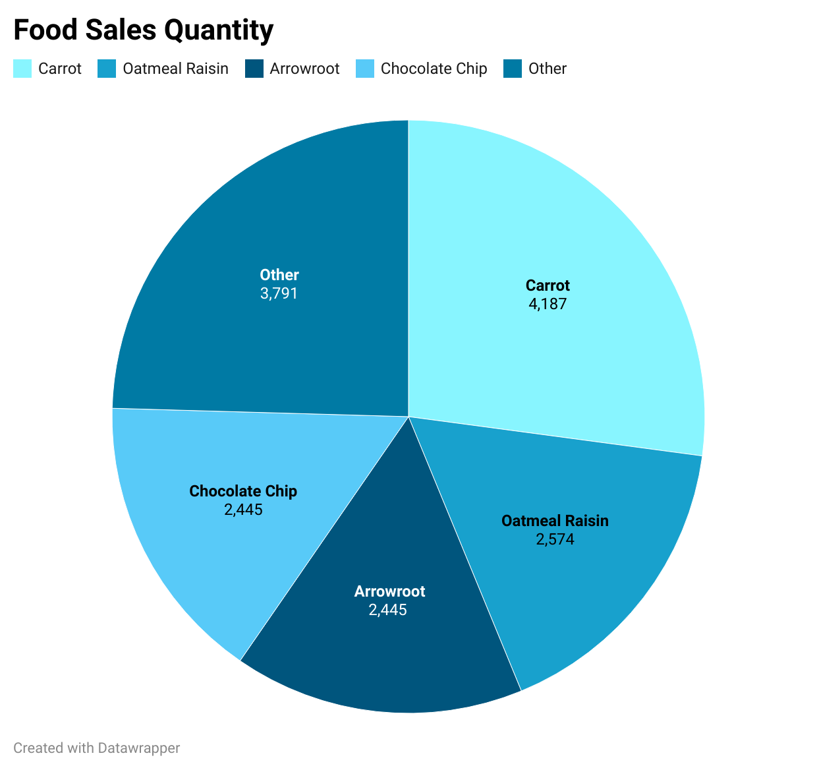

Studies show that carrot bars are more dominant in grocery stores over other snack bars across the country. According to the graph above, carrots accounted for 4,187 in total food quality. In the competing categories, chocolate chips, arrowroot, and oatmeal raisin are also foods making large sums in quantity in 2020. Boston had the most overall sales when it comes to the snack bar category with 88 total products sold over its counterparts in New York, Los Angeles, and San Diego.

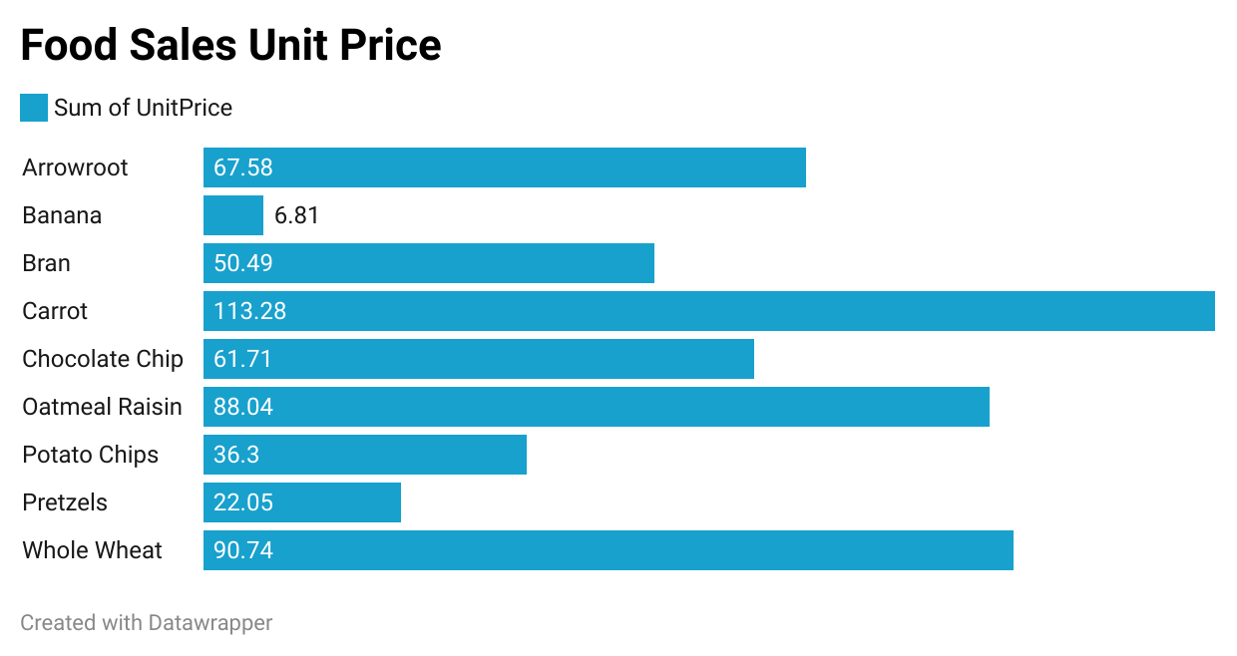

According to the data above, Carrot bars sold a unit price of 113.28 over the last year making it the most profitable snack bar. Oatmeal raisin came close as a second profitable option. In further research, the East coast has the most profitable snack bars over the west coast. The numbers are from 2020 and as new research comes out year over year, this information could change.